Assignment 3

Deadline: Thursday April 22,-2021

* No Assignment will be accepted after the deadline.
* You need to submit the assignment in Hard-form (your own hand-written on paper) over the slate.
* CALCULATOR IS NOT ALLOWED
* Best of Luck.

Name: __________________ Roll No. ______(on each page)

Question # 1: Simplify the following expression and verify the result from truth table before and after simplification

a)

|  |  |  |  |  |  |  |  |  |  |  |  |  |  |  |
| --- | --- | --- | --- | --- | --- | --- | --- | --- | --- | --- | --- | --- | --- | --- |
| __ | __ | __ |  | __ |  | __ |  |  | __ | __ |  | __ | __ | __ |
| A | B | C | + | A | B | C | + | A | B | C | + | A | B | C |

b).

|  |  |  |  |  |  |  |  |  |  |  |  |  |
| --- | --- | --- | --- | --- | --- | --- | --- | --- | --- | --- | --- | --- |
|  |  |  |  |  |  |  |  |  |  |  | **_______** | |
|  | **___** |  |  | **___** |  | **___** | **___** |  | **___** |  | **___** |  |
| A | B | C | + | A | B | C | D | + | A | C( | A | BD) |

Question # 2: (1)Generate Boolean express and then (2)Simplify using Boolean algebra and (3) Draw the logic circuit after simplification.

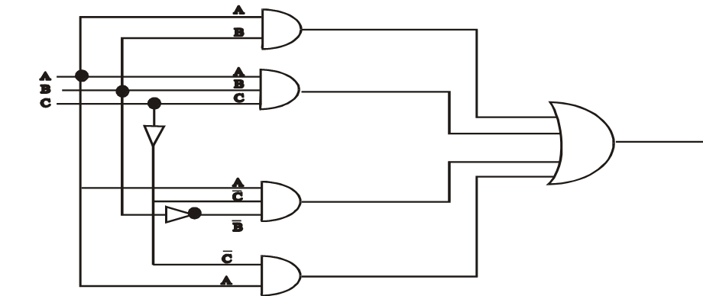a)

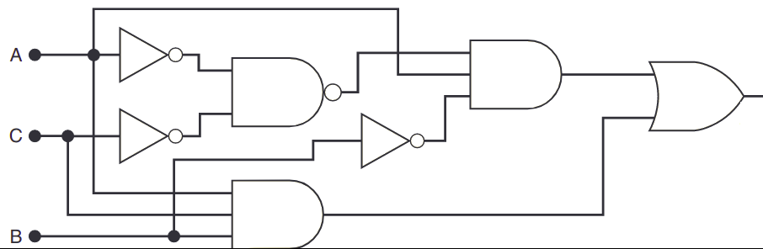b)